Software Development Models

Index
Topics | Page Number
- Agile Model | 1
- Waterfall Model | 2
- V-Model | 3
- Spiral Model | 4

1. Agile Model
The Agile Model is an adaptive, iterative, and customer-focused software development methodology that emphasizes flexibility, collaboration, and continuous delivery. The Agile Model is an iterative and incremental approach to software development. It focuses on flexibility, customer collaboration, and rapid delivery of functional software. Instead of delivering the entire product at once, Agile breaks work into smaller iterations or sprints. Each sprint typically lasts 2–4 weeks and produces a shippable product increment.
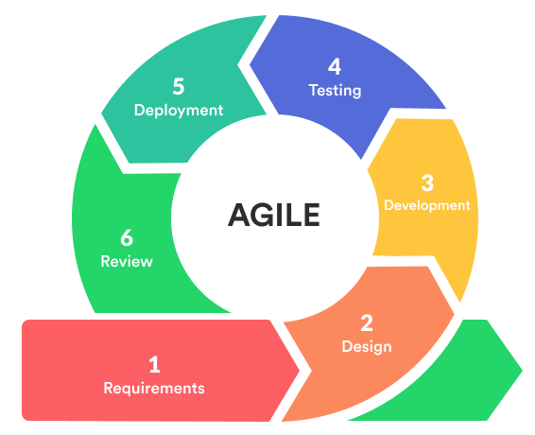
Key Principles:
• Customer collaboration over contract negotiation
• Responding to change over following a strict plan
• Continuous delivery of valuable software
• Self-organizing cross-functional teams
Agile fosters adaptability, making it ideal for projects with evolving or unclear requirements.
2. Waterfall Model
The Waterfall Model is a traditional linear approach where the project flows sequentially through predefined phases such as requirement analysis, design, implementation, testing, deployment, and maintenance. Each phase must be completed before the next begins.
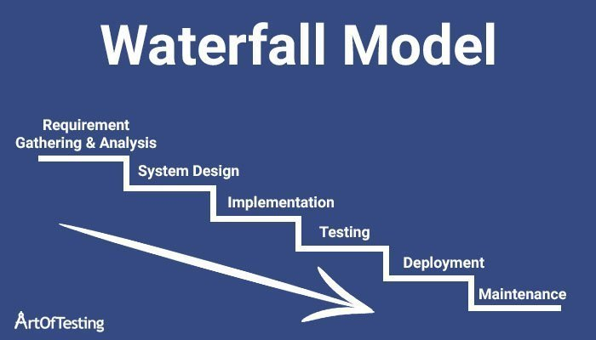
Characteristics:
• Highly structured and documentation-heavy
• No overlapping phases
• Ideal for projects with fixed and clear requirements
Limitations include poor adaptability to changing requirements, making it unsuitable for dynamic environments.

3. V-Model
The V-Model (Verification and Validation Model) extends the Waterfall Model by placing testing phases parallel to development phases. For every development activity, there is a corresponding testing activity.
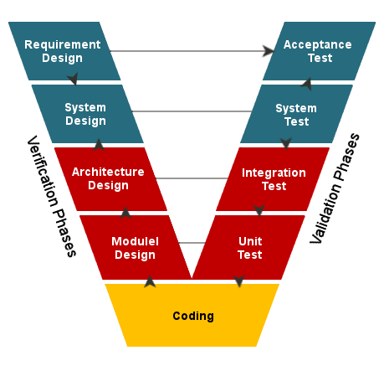
Structure:
• Requirement analysis ↔ Acceptance testing
• System design ↔ System testing
• Architectural design ↔ Integration testing
• Module design ↔ Unit testing
The V-Model emphasizes early test planning and defect prevention, making it suitable for safety-critical projects.

4. Spiral Model
The Spiral Model combines iterative development with risk analysis. It progresses in loops known as ‘spirals’, where each loop includes planning, risk assessment, engineering, and evaluation.
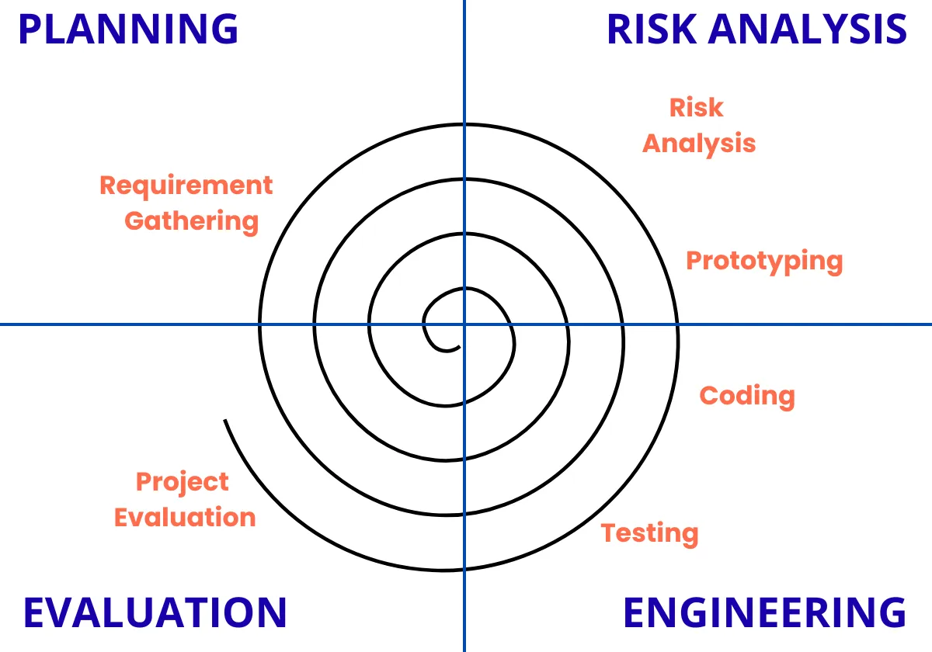
Advantages:
• Focus on risk identification and mitigation
• Flexible and allows repeated refinement
• Suitable for large and complex projects
Due to its complexity and cost, it is generally used for high-risk enterprise systems rather than small projects.

